**Kickstart My Chart – Written Report**

Paul Nisenson

Due 11/7/20

Background: Over $2 billion has been raised using the massively successful crowdfunding service, Kickstarter, but not every project has found success. Of the more than 300,000 projects launched on Kickstarter, only a third have made it through the funding process with a positive outcome.

Getting funded on Kickstarter requires meeting or exceeding the project's initial goal, so many organizations spend months looking through past projects in an attempt to discover some trick for finding success.

Dataset: A database of 4,000 past projects.

Conclusions: From the PivotTables and PivotCharts created, we can draw the following conclusions:

**The most popular categories have the most successful campaigns and success rates.** Of the four most popular categories (Theater, Music, Technology, and Film & Video, in order of most to least successful) three of the categories had more successful than failed campaigns as visually represented in the chart below. None of the categories outside the top four had success rates over 50%.

**Rock (Music) projects are the most likely subcategory to succeed.** While Rock campaigns are second in successful and total volume to Plays, they have been successful 100% of the time. While there may be diminishing returns with increased volume of campaigns, those have not been seen yet.

**As Kickstarter has become more popular, success rates have declined.** When looking at the Launch Date PivotTable and PivotChart, we can filter by year. Filtering the early years (2009 through 2012, 532 campaigns launched) compared with the most recent years (2015 through 2017, 2282 campaigns launched) paints a drastically different picture:

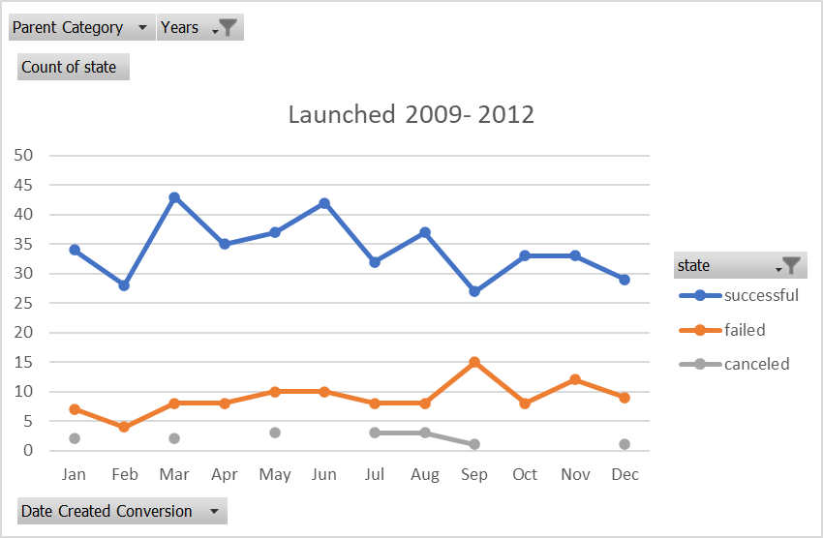

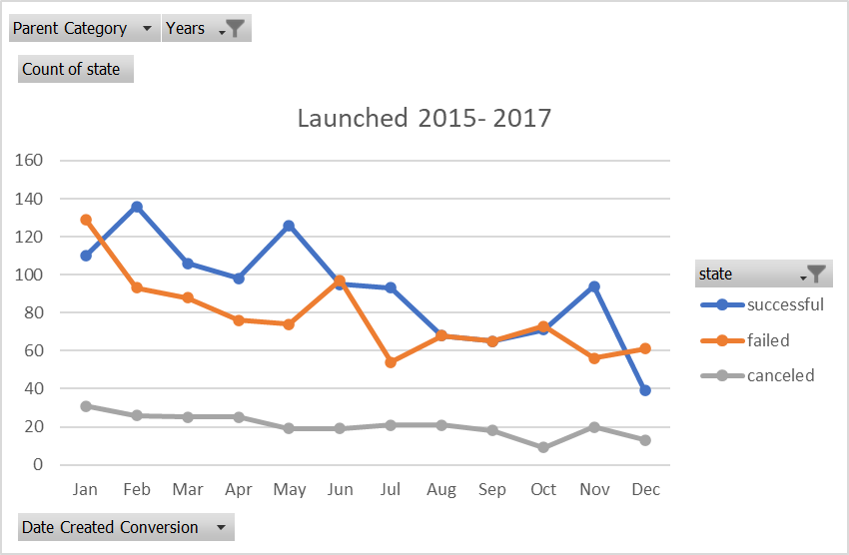

As visually represented above, successes far exceeded failures in the early years of the data presented when there were fewer cases, regardless of the month the campaign was launched. In the later years, the likelihood of failure was equal to or greater than the likelihood of success in half of the months. With November as an outlier, it seems that campaigns were less likely to succeed as the holiday season (December) is approached, possibly due to individuals having less disposable income to spend on campaigns.

Limitations of Dataset: There are several observable limitations of the dataset provided for this project:

**The sample may not be representative of the entire population**. According to the background information provided, there have been over 300,000 Kickstarter campaigns launched of which 1/3 have been successful. The sample provided for this project included just over 4,000 projects (~1.3% of all projects), of which 2,185 were successful. This represents a population with more successful projects than a representative sample. It is possible that in viewing a different 4,000 projects, the success rate or even popularity of a given category/sub-category could be vastly different.

**Lack of quantitative or qualitative data explaining reasons for success or failure of a campaign.** Campaigns can be cancelled for any variety of reasons: poor campaign strategy, oversaturation of a project type/similar projects, timing of launch, economic factors, etc. With the given information, it can be hard to know what was the reason, for example, certain theater projects were successful and other failed. Were certain ones tied in with a celebrity star, existing intellectual property, or past projects with name recognition?

**Lack of data on median donation dollar amount.** While Kickstarter campaigns can often be deemed successful based on the quantity of donors, it is hard to tell from this data whether projects succeeded or failed due to large donors being attracted to projects. By having information on the median donation amount, we can get a better idea if the project was attracting many similar sized donations or if there was a skew to lots of small donations and a few large ones. This information would enable us to target large donors or a large volume of small donors, if either of those scenarios more frequently resulted in successful campaigns.

**Information of how the ‘Spotlight” works.** 100% of spotlighted campaigns in this sample were successful. Without knowing the reasons for spotlighting various campaigns, it is impossible to know if this is causation or correlation. Are campaigns spotlighted after they already reach a high percentage of their funding goal? What are the criteria for getting spotlighted? As a Kickstarter campaign manager, based on this data, I would do anything in my power to get my campaign spotlighted.

Other Possible Graphs/Tables: In addition to the assigned graphs and tables, there are others that I believe would be useful in analyzing the data set:

**Data by Country.** Like anything, Kickstarter requires a certain economy of scale. As we saw above, in total, as Kickstarter grew in popularity, campaigns succeeded less often. However, this phenomenon is likely on a bell curve, where when Kickstarter is not popular enough, campaigns can’t attract enough attention to succeed. When filtering out the two countries with the most campaigns (GB and US, which represent 88% of the sample), campaigns are more likely to fail or be cancelled than succeed:

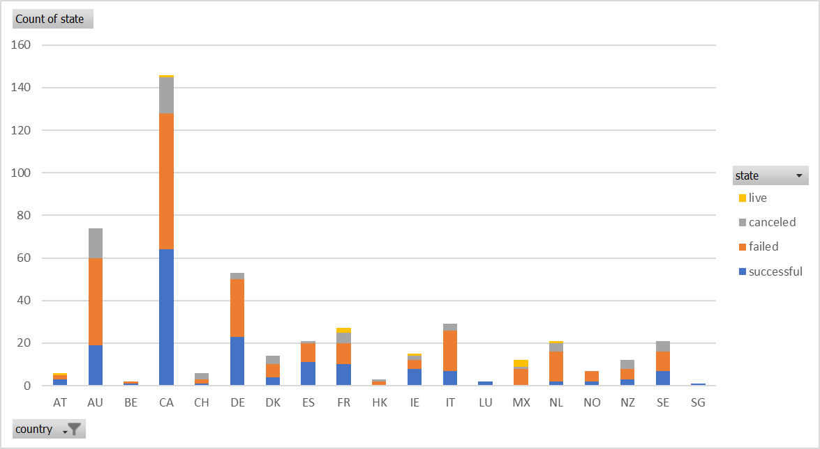

**Data by Goal.** It seems intuitive that the lower the goal dollar amount, the easier it would be to have a successful campaign. By charting successful and failed campaigns by dollar ranges, we could determine the goal amounts with the highest success rates, and at what point those rates decline and eventually become unsustainable. You could look at these metrics with the Y-axis variable as number of campaigns to see the weight of the percentage, or strictly as a percentage with the percent as the Y-axis variable. Both charts below seem to conclude that campaigns are likely to succeed up $5K and then become more unlikely as the amount increases.

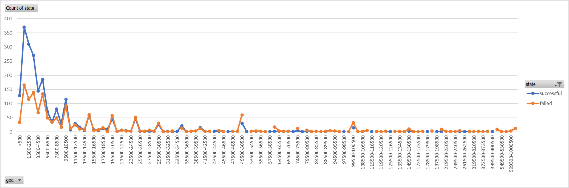

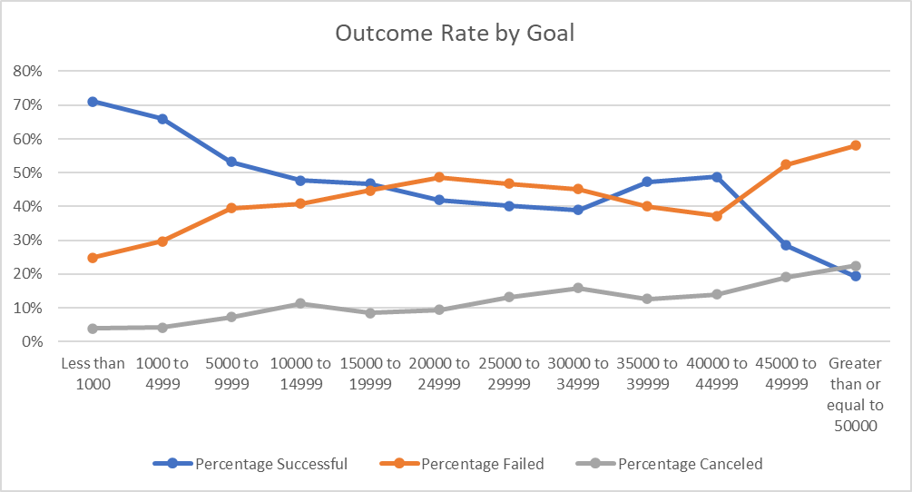

**Data by Year.** As referenced above, we concluded that as Kickstarter became more popular over time, success rates declined. By looking at success and failures as a function of year, we can see the correlation of these stats and identify a saturation point.

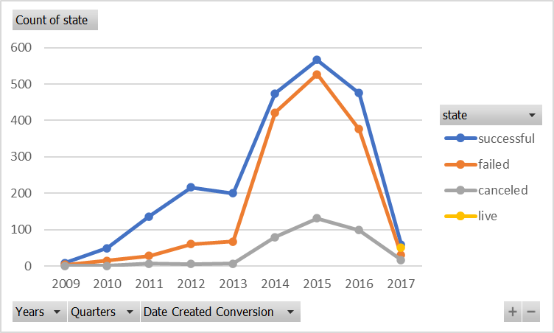

According to the above chart, the point of increasing returns of success occur once the campaigns go over 150 in a year, as we see a widening of the gap between successful and failed campaigns. This trend is maintained around 250 campaigns per year, but then narrows greatly as total campaigns climbs over 800 in 2014. This can be described as a “Kickstarter Boom” in popularity and while the raw amount of successes peaks, the saturation associated with the boom means that almost as many new campaigns has failed.

**Pie charts by category/sub-category.** We could create categorical pie charts either for individual categories showing the successful/failed/cancelled campaigns as a percentage. We could also look at a status (e.g. successful) and represent each category as a percentage of the total status.

Bonus Statistical Analysis: When looking at the “Number of Backers Statistical Summary” for successful and failed campaigns, I believe the Median summarizes the data more meaningfully than the Mean. This is because the variance (how far values are from the mean) is extremely large in both campaign statuses. As such, the Mean is less meaningful.

Additionally, there is more variability in the successful campaigns, as indicated by the variance, standard deviation, and range (max – min) of the successful campaigns compared to failed campaigns. This makes sense because a successful campaign is likely to occur at increasing volumes of backers without a maximum but can also succeed in as few as one backer. Unsuccessful campaigns are likely to not have many backers or else they would be successful except in the event of an extremely large goal amount.